COAL REEF BIOME
The coral reef is one of the major marine biomes. Although it is a relatively small biome, around 25% of the known marine species live in coral reefs.
What is a coral reef?
At first glance, you may think that coral reefs are made up of rocks, but they are actually live organisms. These organisms are tiny little animals called polyps. Polyps live on the outside of the reef. As polyps die, they become hard and new polyps grow on top of them causing the reef to grow.
Does the coral reef eat?
Since polyps need to eat to stay alive, you can think of the coral reef as eating, too. They eat small animals called plankton as well as algae. The algae get their food from the sun by using photosynthesis. This is why coral reefs form close to the surface of the water and in clear water where the sun can feed the algae.
Where are coral reefs located?
Coral reefs need warm, shallow water to form. They form close to the equator near coastlines and around islands throughout the world.
A significant portion of the world's coral reefs are located in Southeast Asia and near Australia. The largest coral reef is the Great Barrier Reef located off of Queensland, Australia. The Great Barrier Reef stretches for 2,600 miles.
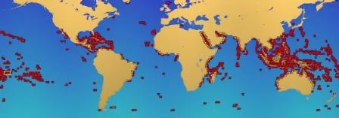
Coral reefs of the world in red

Types of Coral Reefs
There are three main types of coral reefs:
- Fringe reef - Fringe reefs grow close to the shore line. It can be attached to the shore or there may be a narrow strip of water called a lagoon or channel between the land and the coral reef.
- Barrier reef - Barrier reefs grow further from the shore line, sometimes several miles from the shore.
- Atoll - An atoll is a ring of coral surrounding a lagoon of water. It starts out as a fringe reef around a volcanic island. As the coral grows up, the island sinks into the ocean and just the ring of coral is left. Some atolls are so big that people live on them. An example of this is the Maldives.
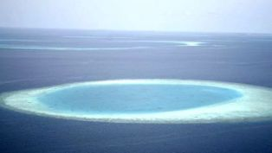
Coral Reef Atoll
Zones of the Coral Reef
After a period of time, coral reefs develop zones. Each zone is inhabited by different kinds of corals, fish, and ocean life.
- Shore or inner reef zone - This area is between the crest and the shoreline. Depending on the shape of the reef, this area can be full of life including fishes, sea cucumbers, starfish, and anemones.
- Crest reef zone - This is highest point of the reef and where the waves break over the reef.
- Fore or outer reef zone - As the reef wall falls off, the waters get calmer. Around 30 feet deep, you will generally find the most populated part of the reef along with lots of different types of coral species.
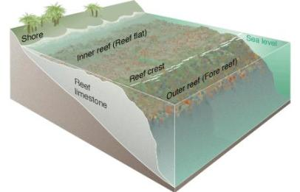
The coral reef can be divided into zones
Coral Reef Animals
All sorts of animals live around a coral reef. This includes many different types of corals such as star coral, brain coral, column coral, cactus coral, and finger coral.
Some of the most strange and interesting creatures in the world live here. Many animals attach themselves to the reef covering nearly every square inch. They include sponges, starfish, anemones, cucumbers, snails, and clams. Also, there are lots of fish swimming around such as cuttlefish, sharks, lionfish, pufferfish, clownfish, and eels. There are 1500 species of fish and 400 species of coral that live on the Great Barrier Reef alone.
Coral Reef Plants
The majority of the plants living on the coral reef are various species of sea grass, seaweed, and algae.
Why are the coral reefs important?
Besides being beautiful, a tourist attraction, and an important part of planet Earth, coral reefs have a positive impact on many people throughout the world. This includes food from fishing, protection of coastlines from erosion, and even medical discoveries such as medicines for cancer.
Are they in danger?
Yes, the coral reefs are slowly being destroyed. Since they grow at such a slow rate, they are disintegrating faster than they can be repaired. Much of the damage is caused by humans, primarily from pollution and overfishing. Even tourists can damage the reefs by standing on them, touching them, or bumping into them with their boats.
Facts About the Coral Reef
- Coral reefs grow very slowly. Large reefs grow at the rate of 1 to 2 cm per year. It's estimated that some of the largest reefs took as long as 30 million years to form.
- Some animals in the coral reef have symbiotic relationships. This means they help each other to survive. The clown fish and the anemone are one example of this.
- Different types of coral grow into different shapes. Some look like mushrooms, some trees, fans, honeycombs, flowers, and even brains.
- The Great Barrier Reef is so big it can be seen from outer space.
- Some coral reefs have turned white because they lose their algae when the water gets too salty or warm.

