The Environment

Biomass Energy
What is biomass energy?
Biomass sounds like a complicated word, but it really isn't. Biomass is just any material made by plants and animals that we can covert into energy.
Biomass has energy stored in it from the sun. Plants get energy from the sun through a process called photosynthesis. Animals get their energy indirectly from the sun by eating plants.
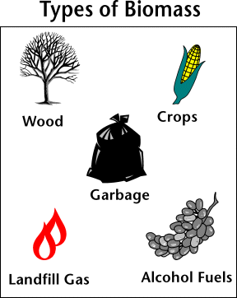
Renewable Energy
Biomass energy is considered a renewable energy source because we can always grow more plants and trees. It is not an infinite resource, however, as there is only so much land and water to grow plants.
Main Types of Biomass Energy
Advertisement | Report Ad
Biomass Energy comes in many shapes and forms. The majority of biomass energy in the United States comes from wood. Other popular forms of biomass include crops such as corn, manure, and even garbage.
How do we get power from biomass?
- Burning - One way to release the energy from biomass is to burn it. The heat from burning biomass can be used to heat homes or to create steam which can then generate electricity. One example of this is burning a fire in your home. You burn the wood, which is the biomass, and it releases energy which heats your home.
- Methane gas - When biomass rots it produces methane gas. Methane gas can be used to make natural gas which is a common source of energy. This means that when garbage rots in landfills, that stinky gas can be used for energy!
- Biofuels - Some crops, like corn and sugar cane, can be converted into a biofuel called ethanol. Ethanol can be used instead of gasoline in many cars. Another type of biofuel is biodiesel. Biodiesel can be made from vegetable oils and animal fats. Biodiesel can be used as heating oil and also to power cars and busses.
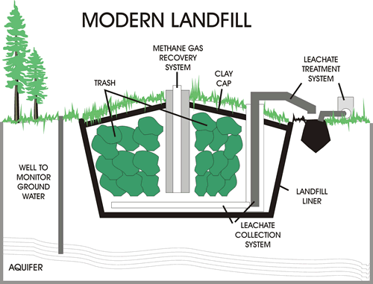
Methane gas from landfills can be used to generate electricity
History of biomass Energy
Biomass has been used as a source of heat energy since man first discovered fire. Many people around the world still burn wood as their primary source of heat during the winter. The use of biofuels such as ethanol has been around for some time as well. It was used as lamp fuel in the United States in the 1800s. The first Model-T Fords used ethanol for fuel until 1908. Recently, biomass and biofuels have become popular as an alternative to fossil fuels such as gasoline.
Advertisement | Report Ad

Are there any drawbacks to biomass energy?
Some of the negatives to using biomass energy include:
- Air pollution from burning
- Releasing green house gasses such as carbon dioxide into the atmosphere
- Burning trash and waste can release harmful chemicals and gasses into the environment
- The land cleared for growing corn and sugar cane can reduce habitats and destroy ecosystems
- The land used for growing biomass could be used to grow other crops for food
- Growing biomass can use fertilizers and other chemicals that can cause water pollution
Despite all the negatives associated with biomass energy, many people believe that it is a better and cleaner alternative to burning fossil fuels such as oil and coal.
Fun Facts about biomass Energy
- The methane gas from cow manure can be used to create energy.
- Most of the gasoline sold in the United States contains some ethanol.
- Garbage is burned for energy as well. This not only makes use of trash for energy, but reduces the amount of trash that goes into landfills. This process is called Waste-to-Energy.
- Farmers create energy from animal manure using tanks called digesters. The digesters produce biogas, which can be used to generate electricity.
- The main ingredient needed for ethanol is sugars. These sugars are found in plants such as corn, rice, sugar cane, barley, switch grass, and even grass clippings.
- Biodiesel is the fastest growing alternative fuel in the United States.

