The Environment

Hydropower Energy
What is hydropower?
Hydropower is power that is generated from moving water such as rivers.
Renewable Energy
Hydropower is a renewable energy source. This means that using a dam or a river to generate electricity doesn't use up any limited resources like coal or gasoline.
How do we get power from water?
Falling or flowing water from a big river has a lot of energy. We can harness this by forcing the water through a pipe called a penstock. As the water flows through the pipe it turns the blades of a turbine which spins an electric generator. As long as the water is flowing, the generator will be able to provide electricity.
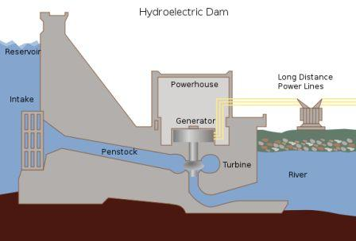
Electricity can be generated by water moving through a dam

Advertisement | Report Ad
There are three main ways that engineers design hydroelectric power plants:
- Storage System - The storage system uses a dam. The dam slows the flow of a river and stores up water in a lake. A portion of the water is released into the river at the bottom of the dam. The fall of the water, and the water pressure from the lake, forces the water through the dam and spins turbine generators. Dams are expensive to build, but they also help control flooding, can create a large recreational lake, and can provide fresh water for surrounding towns.
- Run-of-the-river System - In a run-of-the-river system the turbines are spun by the natural flow of the river. These systems have the advantage of not creating a huge lake and flooding the area above the dam. As a result, they have less overall impact on the environment. However, in order to provide continuous electricity, the river they use must stay full throughout the year, as the flow is not regulated by a dam.
- Pumped Storage System - This system is like the storage system except it uses pumps to pump used water back up into the reservoir. The way this works is that during the night, when electricity use is much less, it uses the extra electricity to pump the water back up to the top of the dam and refill the reservoir. This improves the overall efficiency of the hydropower plant.
Go here to read about the ocean power technologies tidal and wave power.
History of Hydropower
Using rivers to power mechanical devices is not a new concept. As far back as ancient times, thousands of years ago, people used hydropower to perform tasks such as grinding grain into flour. In the late 1800s scientists first figured out how to use hydropower to generate electricity. The first hydroelectric power plant was built in Wisconsin in 1882. Since then, many more power plants have been built in the United States including the Hoover Dam in 1936 and the Grand Coulee Dam in 1942.
Are there any drawbacks to hydropower?
Like any power source there are some drawbacks to hydropower. One drawback is the loss of land and the damage to the local ecosystem caused when a lake is created by a dam. This can also cause people to have to relocate and leave their homes. Another disadvantage is methane emissions generated by the reservoirs. Dams and turbines can also hurt fish and disrupt their migration to spawning grounds.
Advertisement | Report Ad
Fun Facts about Hydropower
- There are over 2,000 hydroelectric power plants in the United States.
- Many countries, such as Norway and Brazil, get a significant portion of their electricity (as much as 85%) from hydropower.
- The largest dam and hydroelectric power plant in the world is the Three Gorges Dam in China. It provides 22,500 Megawatts of electricity!
- Most of the dams in the United States were not built to supply power. They were built for flood control and to provide local irrigation.
- A large portion of the hydropower generated in the United States occurs in the western states. The number one producer of hydropower is Washington state which produced 29% of the nations hydropower in 2011.

