The Environment

Solar Energy
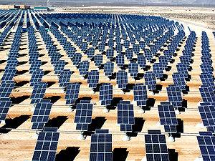
What is solar power?
The primary source of all energy on planet Earth is from the sun. Solar power is power generated directly from sunlight. Solar power can be used for heat energyor converted into electric energy.
Renewable Energy
When we use solar power, we don't use any of the Earth's resources like coal or oil. This makes solar power a renewable energy source. Solar power is also clean power that doesn't generate a lot of pollution.
Solar Power for Heat
Advertisement | Report Ad
Solar power can be used for heating up homes and other buildings. Sometimes solar power for heating can be passive. This is when there are no mechanical components used to move the heat around. Passive heating helps to keep houses warm in the winter, to heat up swimming pools, and even makes our car warm when we park it outside (which is nice in the winter, but not so much on a hot summer day).
Active heating is when there are mechanical components to help move the heat around. The sun could be used to heat up water or air that is then pumped around a building to provide even heat in all the rooms.
Solar Power for Electricity
When most of us think of solar power, we think of the solar cells that turn rays of sunshine into electricity. Solar cells are also called photovoltaic cells. The word "photovoltaic" comes from the word "photons", which are particles that make up sunlight, as well as the word "volts", which is a measurement of electricity.
Advertisement | Report Ad
Today solar cells are commonly used in small handheld devices like calculators and wrist watches. They are becoming more popular for buildings and homes as they become more efficient. One nice thing about solar cells is that they can be placed on the roof of a building or home, not taking up any extra space.
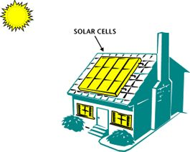
Solar cells on a house used for making electricity

How do solar cells work?
Solar cells convert the energy of photons from the sun into electricity. When the photon hits the top of the cell, electrons will be attracted to the surface of the cell. This causes a voltage to form between the top and the bottom layers of the cell. When an electric circuit is formed across the top and the bottom of the cell, current will flow, powering electrical equipment.
Advertisement | Report Ad
It takes a lot of solar cells to power a building or a home. In this case, a number of solar cells are connected into a large array of cells that can produce more total energy.
History of Solar Power
The photovoltaic cell was invented in 1954 by researchers at Bell Labs. Since then, solar cells have been used on small items such as calculators. They have also been an important power source for spaceships and satellites.
Starting in the 1990s the government has funded research and offered tax incentives to people using clean and renewable power such as solar energy. Scientists have made advances in the efficiency of the solar cell. Today solar cells are around 5 to 15% efficient, meaning a lot of the energy of the sunlight is wasted. They hope to achieve 30% or better in the future. This will make solar energy a much more economical and viable energy alternative.
Are there any drawbacks to solar power?
Solar power has two major drawbacks. One drawback is that the amount of sunshine in a specific place changes due to the time of day, the weather, and the time of the year. The other drawback is that with current technology it takes a lot of expensive photovoltaic cells to produce a decent amount of electricity.
Fun Facts about Solar Power
- The world's largest solar thermal plants are located in the state of California.
- Many large photovoltaic plants are being built around the world. Some of the largest are located in China, Canada, and the United States (Nevada).
- If only 4% of the world's deserts were covered in photovoltaic cells, they could supply all of the world's electricity.
- Many people think that as solar panels become more efficient and less expensive they will become a standard feature of new homes and buildings.
- In 1990 a solar powered aircraft flew across the United States using no fuel.
- Albert Einstein won a Nobel Prize in 1921 for his research into photovoltaic power.

